Recharging Your Battery

Our bodies and minds require maintenance to function optimally and sometimes the things that help us stay well get pushed out when we are stressed. Below are some examples of what can “drain” us and “recharge” us. Take a few minutes to reflect on what is currently draining you and what can recharge you. Make a plan to stop something that is draining, continue something you are already doing that recharges you and start something that helps you recharge.

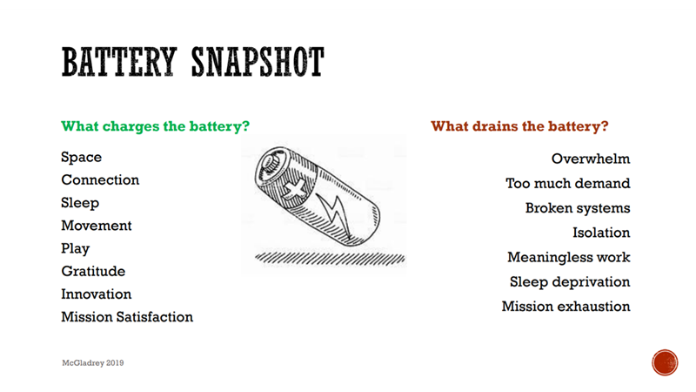

What Drains Your Battery? | What Charges Your Battery?
- _______________  - _______________  - _______________  - _______________  - _______________  - _______________ | - _______________  - _______________  - _______________  - _______________  - _______________  - _______________
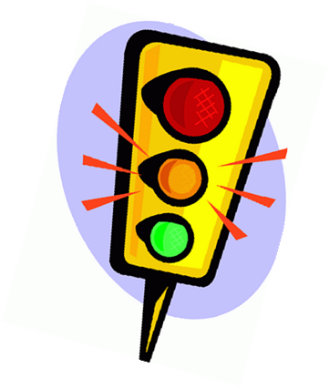
STOP:
KEEP:
START:

McGladrey & Cypers, 2020

